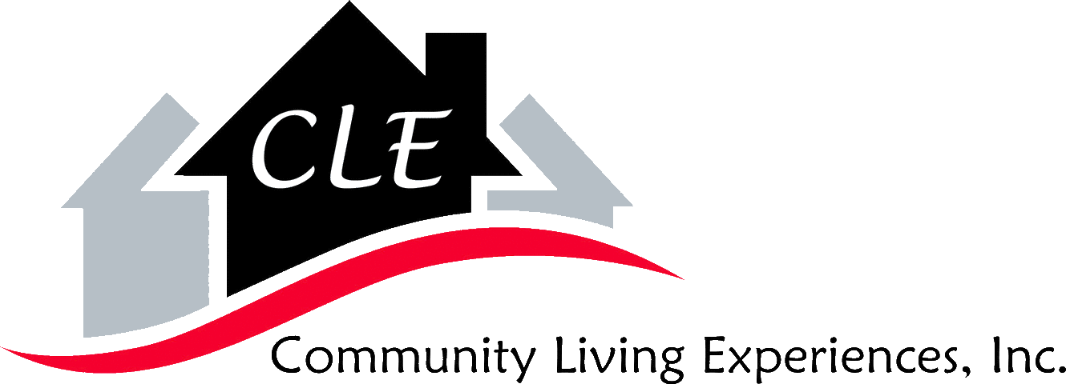

Dear Guardian,
CLE is gathering photos of our consumers in an effort to use them for our brochures, websites and during job and provider fairs.
We would appreciate your permission to use these images.
CLE continues to put the consumers we serve best interest first and we will NOT share any images of our consumers that would not portray them in the best ways possible.

Thank You
Your Cooperation Is Appreciated
Community Living Experiences, Inc.

2939 Donnylane Blvd. Columbus Ohio 43235
Phone 614-588-0320 Fax 614-588-0329

Photo Clearance

I, _______________________________________________ (Guardian) give my consent for Community Living

Experiences, Inc. to use pictures of ________________________________________________________ for:

(Please place an X on all that apply)

___ Non-Media Advertising- (CLE brochures, CLE website, Facebook and Job and Provider Fairs)

___ Picture Only, No Name

___ Back of Head ONLY

___ For CLE Brochure ONLY

___ Public Media- (Broadcasting-Television, Radio)

___ Other_________________________________________________________________

___ I DO NOT GIVE CLE PERMISSION TO USE ANY IMAGES

____________________________________________________________ ____________________
INDIVIDUAL SIGNATURE DATE

____________________________________________________________ ____________________
GUARDIAN SIGNATURE DATE

