|  |  |  |  |
| --- | --- | --- | --- |
|  | | | |
| **As of the Advisory Levels in our counties change, we must continue to practice safety. All staff must wear mask during their shifts, use social distances whenever possible and use gloves for personal hygiene.**  **DSP Week Sept. 14-18, 2020**  CLE has the upmost respect and appreciation for our DSPs. We could not provide services without you, as you are our frontline. Please accept our tokens of appreciation and know that we truly appreciate the hard work and dedication you bring to your job.  As we deal with this current Pandemic, CLE will continue to offer activities for our consumers and we will appreciate your continued help with keeping the consumers in attendance and engaged.    Follow us on Facebook  https://www.facebook.com/pg/cleagency  What’s new at CLE?  Get the latest info  You can check out our newly updated website  https://www.cleohio.com/  This will take you directly to the Employee Portal |  |  |

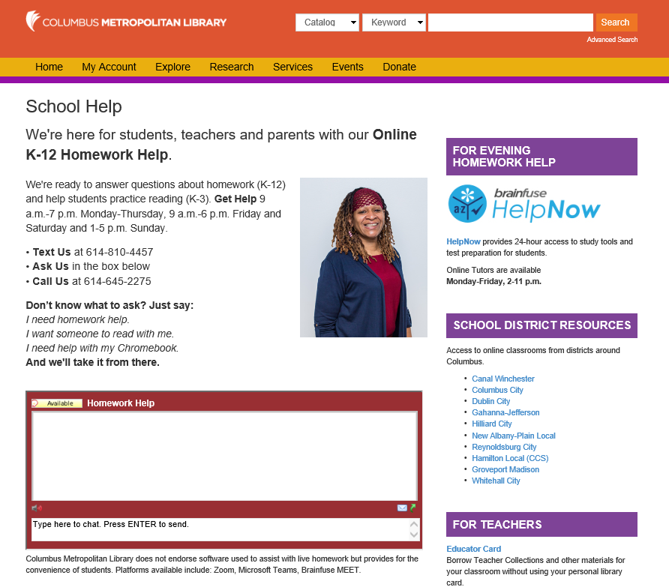



ONE-TIME GRANT for Businesses and **Residents of Gahanna**

Don’t Stress

Columbus

Metropolitan

Library

Offers FREE homework assistance for grade K-12

**Community Resources**

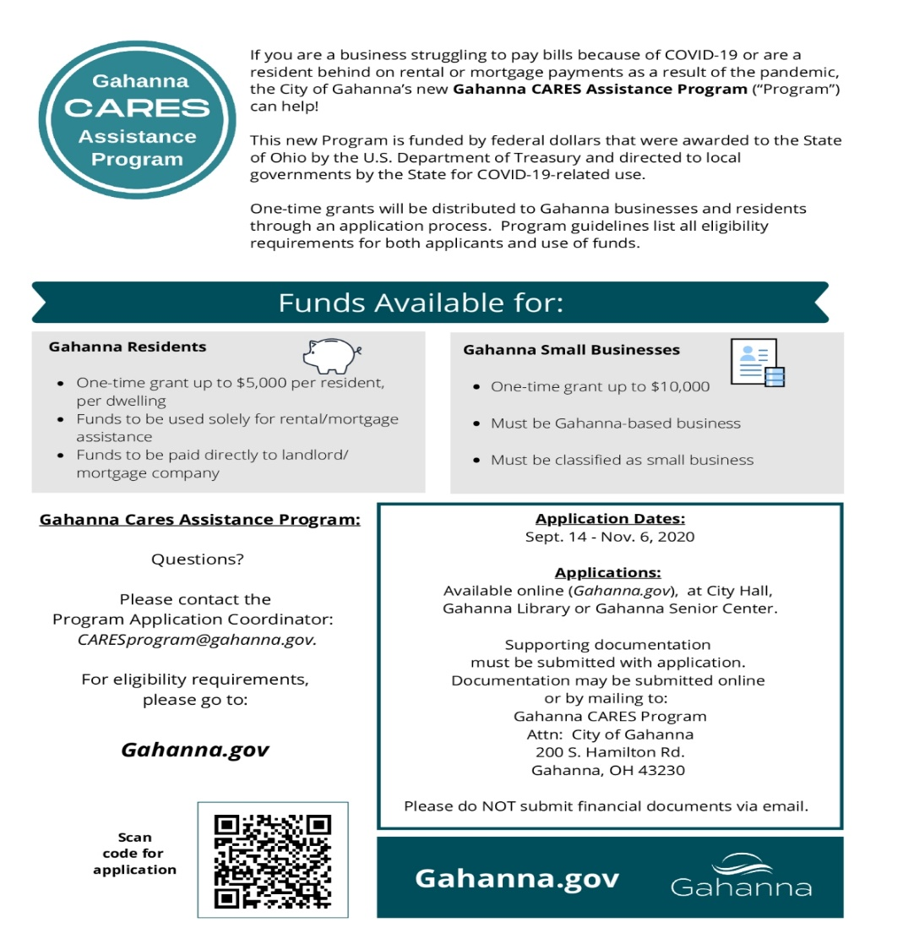 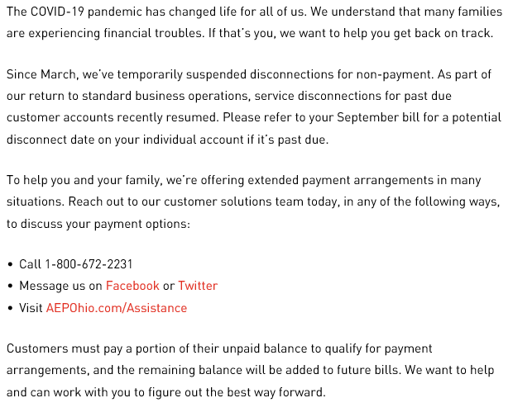

**CLE is NOT affiliated with either of the above agencies and cannot make any promises; we are only providing you the info.**