WonderLight’s Christmas in Ohio
Dates: November 13, 2020 – January 3, 2021 (5:30 p.m. – 10:00 p.m.) rain, shine or snow!
Location: National Trail Raceway (2650 National Road SW, Hebron, OH 43025)
Details: Drive through this holiday light display and see 1 million LED lights as you listen to traditional and newer Christmas music.
Website: WonderLight’s Christmas in Ohio
Conservatory Aglow at the Franklin Park Conservatory
Date: November 14, 2020 – January 10, 2021
Location: Franklin Park Conservatory
Details: Conservatory Aglow returns for the biggest and brightest holiday show in the history of the Conservatory, extending beyond the building and into The Scotts Miracle-Gro Foundation Children’s Garden as well as the Grand Mallway. Be sure to check the website for dates and times of the various events and special prices for this year. Conservatory Aglow is a Special Engagement that occurs November 14th, 2020 – January 10th, 2021 from 5-9pm. On these dates, General Admission will end at 4pm.
The outdoor Conservatory experience will be twinkling, glowing, and magical thanks to thousands of lights presented in stunning displays. This is a breathtaking holiday light display! Conservatory Aglow includes: Website: Conservatory Aglow -Exhibitions, Gardens and Collections (the Scotts Miracle-Gro Foundation Children’s Garden will close at 9pm)
-Botanica Gift Shop and Greenhouse

Wildlights at the Columbus Zoo and Aquarium
Dates: Thursday, November 19, 2020 (Member Preview Night)- January 3, 2021 (closed Thanksgiving, Christmas Eve and Christmas)
Location: Columbus Zoo and Aquarium
Details: Millions of lights illuminate the zoo in one of the best holiday light displays in the city!
Website: Columbus Zoo and Aquarium
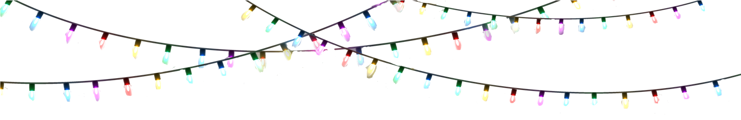

Butch Bando’s Fantasy of Lights
Dates: November 20, 2020 – January 3, 2021
Location: Alum Creek State Park Campgrounds (3311 South Old State Rd., Delaware, Ohio 43015)
Details: Stay warm and toasty in your car as you travel through this drive-thru light show spectacular. They have a Santa mail option this year too!
Website: Fantasy of Lights

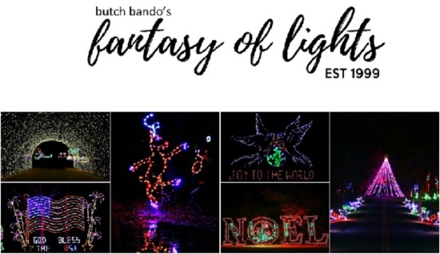

Easton Town Center Holiday Light Display
Dates: November 20, 2020 is the first date for the tree being lit, but lights remain throughout the holiday season.
Location: Easton Town Center
Details: Shop and stroll through the sidewalks of The Strand. Enjoy the sight of the tree as it reflects on the Central Park Fountain. Grab something festive to drink in Easton’s newest district. Wherever you may be, experience the delight of over two million lights as they illuminate the Center. Be sure to keep your eyes open – you never know when you will happen upon an enchanting seasonal surprise!
Website: Easton Town Center

Holiday Lights at the Columbus Commons
Dates: November 20, 2020 – January 5, 2021
Location: Columbus Commons
Details: From dusk until 11:00 p.m., you can stroll through Columbus Commons and enjoy the lights.
Website: Columbus Commons
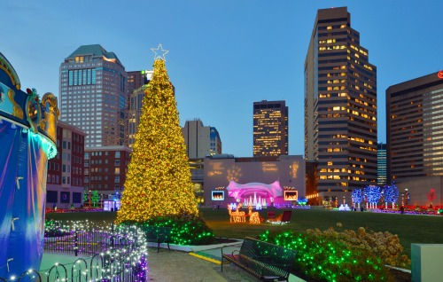
Columbus Commons Holiday Lights

Scioto Mile Holiday Light Display
Dates: Beginning November 20, 2020
Location: Scioto Mile
Details: Walk along the Scioto Mile and view the lights on 150 trees and thousands of lights!
Website: Scioto Mile

Winter Wonderland at Creekside Park
Dates: Begins mid-November through the end of December
Location: 117 Mill Street Gahanna Ohio
Details: A beautiful light display! Be sure to check the website for updates for 2020, as things will be set up differently.
Website: Gahanna Creekside

State Auto’s Christmas Corner
Dates: TBD – Jan. 4: Daily from 6 – 8 a.m.; 5:00 – 11:30 p.m.; until 12:30 a.m. on Fridays and Saturdays
Christmas Eve: 3:00 p.m. until 8 a.m. Christmas Day
Location: 518 E Broad St., Columbus, OH 43215
Details: A life Sized Nativity Scene can be found at State Auto Headquarters. They will not have weekend concerts this year due to COVID-19.
Website: State Auto’s Christmas Corner
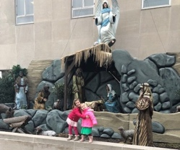

Neighborhoods and Houses with the Best Christmas Lights

Lights of Glenross
Times: Runs Sunday-Thursday from 5-9 p.m. and Friday-Saturday from 5-11 p.m. (Begins November 26, 2020 until New Year’s Day). Location: Delaware, Ohio between US 23 and South Old State Road
Details: Over 300 houses for 2020 choreographed to Christmas music! Tune to 94.1 FM to listen and enjoy. Cost: This neighborhood light show is free, but in 2020 consider donating to The People in Need in Delaware County through the link on their website. However, they want people to have a FUN Christmas activity this year! Facebook Page: Lights of Glenross Website: Lights of Glenross
Griswold Delaware
Dates/Times: Starts Thanksgiving night through January 1, 2021 from 6 pm – 12 am.
Location: Delaware, Ohio Details: There will be even more lights than last year! There are 120,035 lights and 235 hours of time to put up. The whole house and yard are decked out. This is something you will want to see in person. Wow! Facebook Page: Griswold Delaware
Lucy Depp Park Light Show
Dates/Times: Runs Sunday-Thursday from 4-10 p.m. and Friday-Saturday from 4-11 p.m. (until New Year’s Day). The first night is Black Friday in 2020!
Location: Frabell Drive, Powell, Ohio Details: It’s double the size of last year! Donations go to Peace for Paws! Tune in to 87.9 to hear the show! Website: Lucy Depp Park Light Show
Stepp Christmas Display
Location: 3112 Melbury Drive, Columbus, Ohio 43221 (Hilliard). Details: The show is back for 2020! Website: Making Spirits BrightDazzling Christmas Lights First Night
Location: 649 Old Coach Road Westerville, Ohio 43081
Details: 6:00 p.m. – 11:00 p.m. The display is one house with over 100,000 Dazzling Christmas Lights that dance to music. Tune your car radio to 90.1 FM. and bring can food items. The display runs November 27, 2020 to December 31, 2020 Sunday-Thursday 6 p.m. to 10 p.m. Friday and Saturday 6 p.m. to 11 p.m. This is a free event all season long. Website: Dazzling Christmas Lights

Christmas Lights: Locations Outside of Columbus

Christmas at Kingwood
- Located in Mansfield, Ohio
Dates: See website as information will be updated soon for 2020
Location: Kingwood Center Gardens (50 N. Trimble Rd. • Mansfield, Ohio 44906)
Details: The rooms of Kingwood Hall are decorated to depict various Christmas carols. Outside you’ll find thousands of lights. Fun holiday light display!
Website: Kingwood Center Gardens

Dickens Victorian Village: Courthouse Light Show
- Located in Cambridge, Ohio
Dates: November 1, 2020 – January 1, 2021
Location: Guernsey County Courthouse lawn, Wheeling Avenue
Details: The historic courthouse comes alive with an interactive light and sound show. Cambridge is such a charming city. After, take a stroll and see various life-size, hand-crafted mannequins that are arranged along Wheeling Avenue. Read more here about Dickens Victorian Village.
- With the Coronavirus pandemic a huge global issue, Dickens Victorian Village will curtail many activities for the 2020 season. The mannequins will be on display in historical downtown Cambridge, the Guernsey County Courthouse Light Show will run nightly, two Victorian Teas are scheduled, two cemetery tours and trolley tours.
Website: Dickens Victorian Village

