DSP RETENTION BONUS

DSP Bulletin February 2023

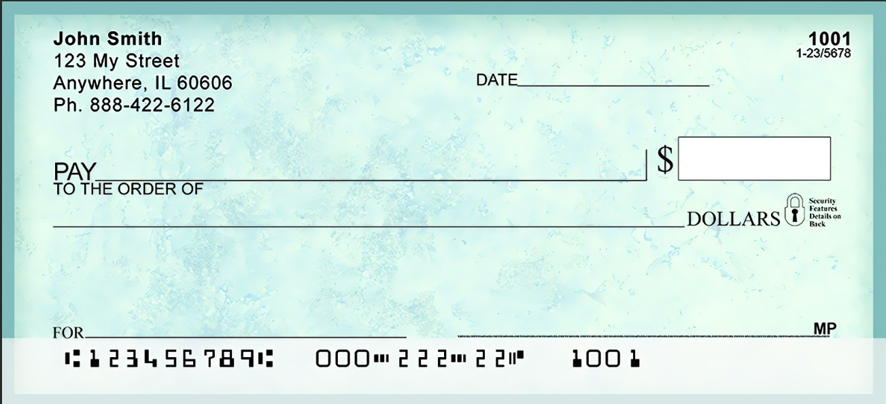

Depends on employment

Amount is dependent on employment dates

**Before 3/15/2023**

Community Living Experiences, **INC.**

**Direct Support Professional**

**Direct Support Professional**

*The Ohio Department of Developmental Disabilities announced and approved a plan to provide retention payments to Direct Support Professionals (DSPs) employed by agencies and independent providers who provide waiver services.*

**What do I have to do to get more money? When do I get the payments?**

Although these payments were approved in mid-December, the payment period started April 1, 2022. You are eligible for multiple payments if you were employed with this agency from April 1 through June 30 2022, July 1st through Sept 30, 2022 and/or October 1 through December 31, 2022.

If you have worked for the same agency consistently during those times, and remain employed when the payments are made to staff, you will get three payments, between Mid-February and March 15, 2023.

To get additional payments, you must stay employed with your agency. Additional payments for employment periods January 1, 2023 through March 31, 2023 and April 1 through July 31st are expected by June 15 and Sept. 15, 2023. **THIS WILL BE A SEPARATE DIRECT DEPOSIT CHECK**, Not included on routine paycheck.

|  |  |
| --- | --- |
| **I worked** | **I will get paid\*** |
| April 1 - June 30 2022 | by March 15, 2023 |
| July 1 - September 30 2022 | by March 15, 2023 |
| October 1 - December 31 2022 | by March 15, 2023 |
| January 1 - March 31 2023 | by June 15, 2023 |
| April 1 - June 30 2023 | by September 15, 2023 |

*THESE DATES ARE TENATIVE

**Examples**

* A DSP was hired in November 2022 and is still employed with CLE, they will receive one set payment amount by 3/15/2023
* Another staff was hired August 2022 and is still employed with CLE, they will receive two set payment amounts by 3/15/2023 (Both will appear on one check)
* Yet another staff was hired before June 30, 2022 and is still employed with CLE, they will receive three set payment amounts by 3/15/2023 (All will appear on one check)

***DSPs that remain employed with CLE are anticipated to receive additional Bonuses by June and September 20***

It is MANDATORY that ALL EMPLOYEES USE BRITTCO! ………..ABSOLUTELY NO EXCEPTIONS

**Supervisors will be using Brittco to verify your time worked, which will be communicated to Payroll and directly reflect the time you will be paid for.**

***(Continue to sign in and out and submit timesheets as well until you are told they are no longer needed)***

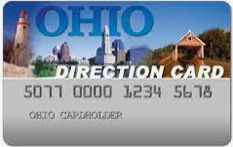

**EMPLOYEE INSURANCE BENEFITS ACCESS INFO IS NOW ON OUR WEBSITE**

**Go to Employee Portal then click CLE Insurance**

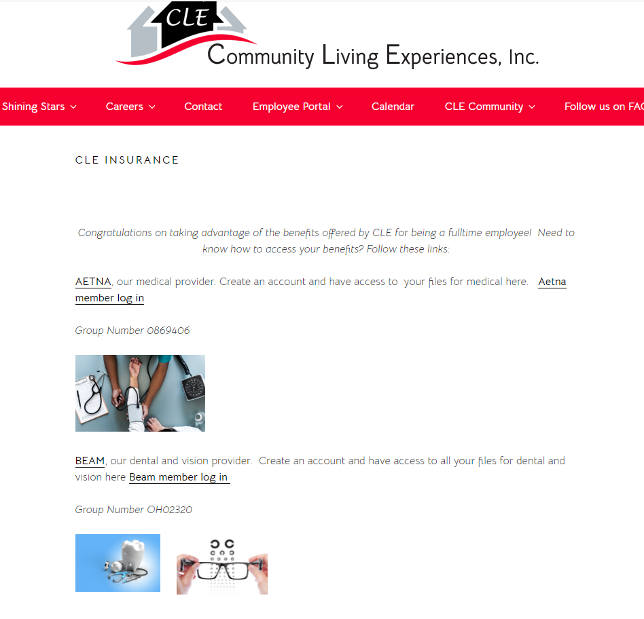

**CLE continues to offer referral BONUSES.**

**Referring Employee will receive a $50.00 gift card once the referred employee has completed**

**3 months of employment with CLE**

**AND**

**Another $50.00 gift card after that employee has completed 6 months of employment with CLE**



*Please contact HR if you are due a referral bonus or are referring a new employee.*

The United States Department of Agriculture, Food and Nutrition Services announced that the Supplemental Nutrition Assistance Program (SNAP) emergency allotments are ending after nearly three years. The last month of emergency allotments is February 2023.

Starting in March, clients will only get their regular SNAP payment loaded to their EBT card in the first half of the month.

There will be no second payment later in the month.

SNAP Emergency Allotment will end March 2023



**Check US Out** on Facebook & Our website